
BENAZIR BHUTTO SHAHEED UNIVERSITTY LIYARI

LAB MANUAL

- Members :
  - Muhammad Usman,
  - Mujahid Khan,
  - Shahab Ali
- YEAR/ SEMESTER : 6th (B)
- DEPARTMENT : Computer Science
- INSTRUCTOR : Anwar Ali
- COURSE TITLE : Artificial Intelligence

How to Install Anaconda on Windows
Anaconda is a popular open-source distribution of Python and R and is widely used in the field of data science, machine learning and scientific computing. It contains Jupyter, Sypder, etc. that are well capable of handling a large number of data sets and processes as per user's need. It helps in simplifying package management and deployment, which promotes a robust environment for various data-related tasks. In this guide, we're going to walk you through the steps to install Anaconda on Windows OS.
Download the Anaconda Installer
We will start the process by downloading the Anaconda Installer by following these three simple steps as mentioned below:
Step 1: Visit the Official Website
Head over to anaconda.com and install the latest version of Anaconda. Make sure to download the “Python 3.13.1 Version” for the appropriate architecture.
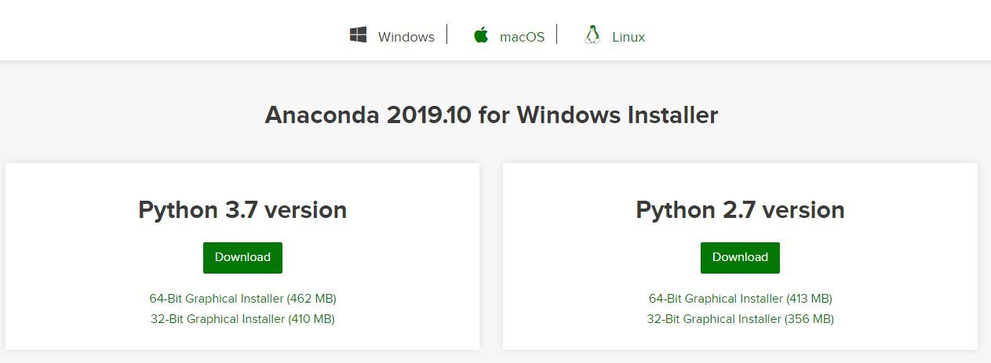
Step 2: Select the Windows Installer
Choose the appropriate installer (based on your system's architecture) i.e. 64-bit (for modern systems) or 32-bit (for older system)
Step 3: Start the Downloading Process
Select the location where you want to save the file and click "Save" to start the downloading process.
Run the Anaconda Installer
Once the installation is completed, now we will see how to setup Anaconda Installer in your Windows PC. Let's check it out:
Step 1: Begin with the installation process
Navigate to the downloaded file, make a double-click on the .exe file and start the installation process.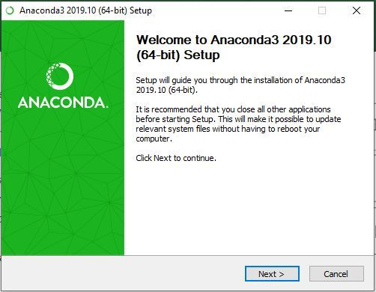
Step 2: Getting through the License Agreement
Follow the on-screen instructions, read the license terms & agreement and proceed ahead.
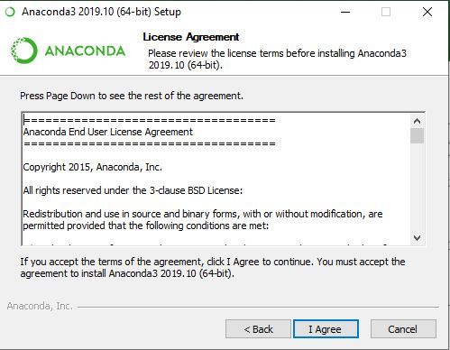

Step 3: Select Installation Type
Select Just Me if you want the software to be used by a single User else you can select All Users (for all users on the system)
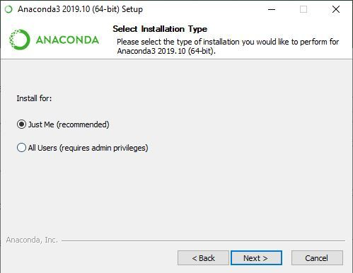
Step 4: Choose Installation Location
Select the path where you wish to install the file extractor and click "Next" to proceed ahead.
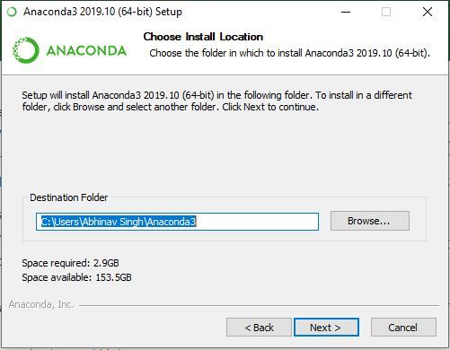

Step 5: Advanced Installation Option
Choose whether to add Anaconda to your system PATH environment variable. Also note that adding Anaconda to the PATH can interfere with other software and decide whether to register Anaconda as the default Python.
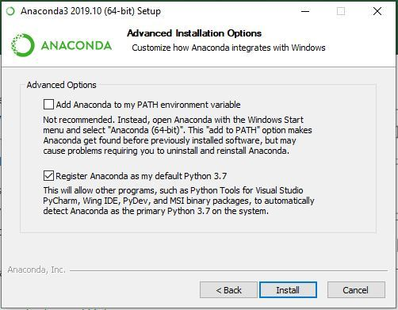
Step 6: Getting through the Installation Process
Click Install to start the Anaconda Installation process.
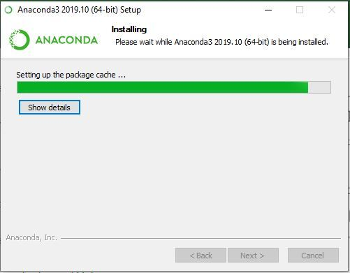
Step 7: Finishing up the Installation
Once the installation gets complete, click Finish to complete the process.
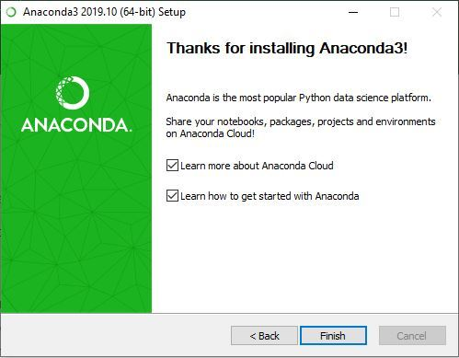
Working with Anaconda
Once the downloading, installing and verification of the Anaconda for Windows PC is competed, you can start exploring and get familiar with its features.
Access Anaconda Navigator
Once the installation process is done, Anaconda can be used to perform multiple operations. To begin using Anaconda, search for Anaconda Navigator from the Start Menu in Windows PC.
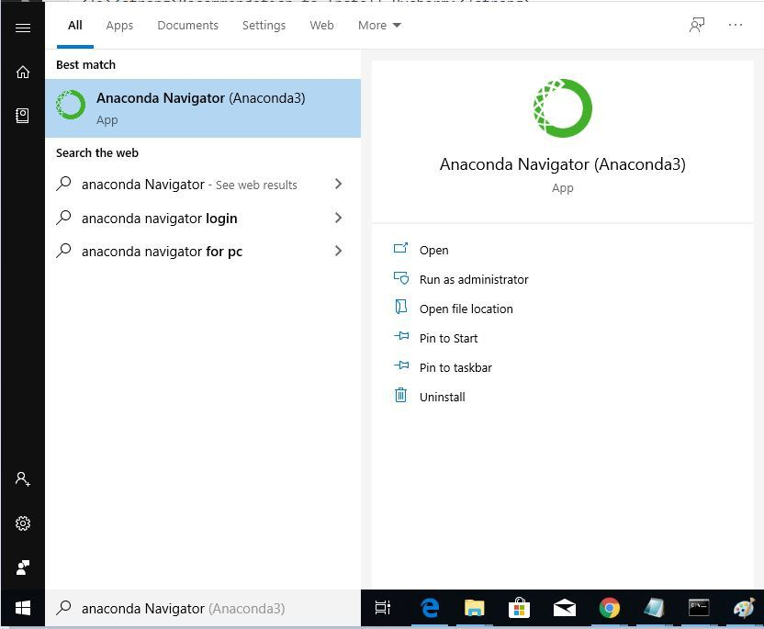
Launch Jupyter Notebook:
On the Navigator home screen, you will see tiles for several applications, including Jupyter Notebook. Click the Launch button underneath the Jupyter Notebook tile.
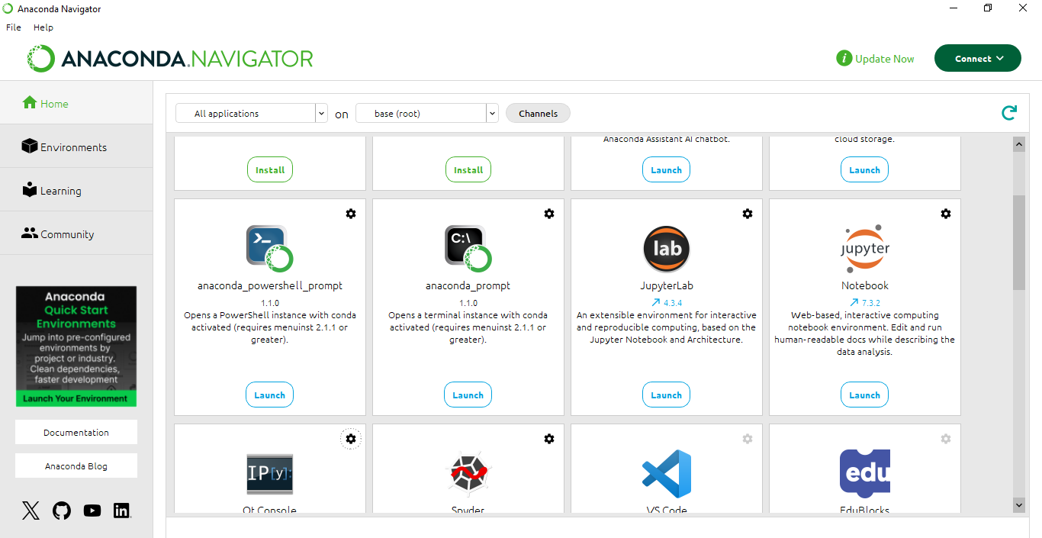

Smart Traffic Light Control (Multi-Agent CSP vs Deep Q-Learning)

1. Introduction
Traffic congestion at urban intersections leads to long delays, high fuel consumption, and increased emissions. Traditional fixed-time signals cannot adapt to changing traffic patterns.
This project aims to develop a data-driven traffic signal control system that compares the performance of two distinct AI models:
- Multi-Agent CSP, which uses rule-based optimization to coordinate intersections.
- Deep Q-Learning, which learns adaptive policies through continuous interaction with traffic data.
The comparison evaluates which technique provides better congestion management and signal timing efficiency.

2. Problem Statement
Design and implement an intelligent traffic signal control system that:
• Learns from historical traffic data.
• Produces adaptive signal timing decisions to minimize congestion and waiting time.
• Compares the effectiveness of Multi-Agent CSP and Deep Q-Learning under identical conditions.
Performance is evaluated through congestion cost metrics, representing average waiting time and queue length across intersections.

3. Objectives
• Clean and preprocess traffic datasets (AADT and signal data).
• Normalize and transform numerical features using z-score scaling.
• Split data into 80/20 training and testing sets.
• Implement Multi-Agent CSP for rule-based optimization of signals.
• Implement Deep Q-Learning for adaptive signal control using reinforcement learning.
• Visualize model convergence and compare both approaches using congestion reduction metrics.

4. Dataset & Preprocessing
Files: The notebook loads multiple CSV datasets (AADT and signal data) for model training and testing.

Steps:
- Load CSVs: Import files using pandas and review basic statistics.
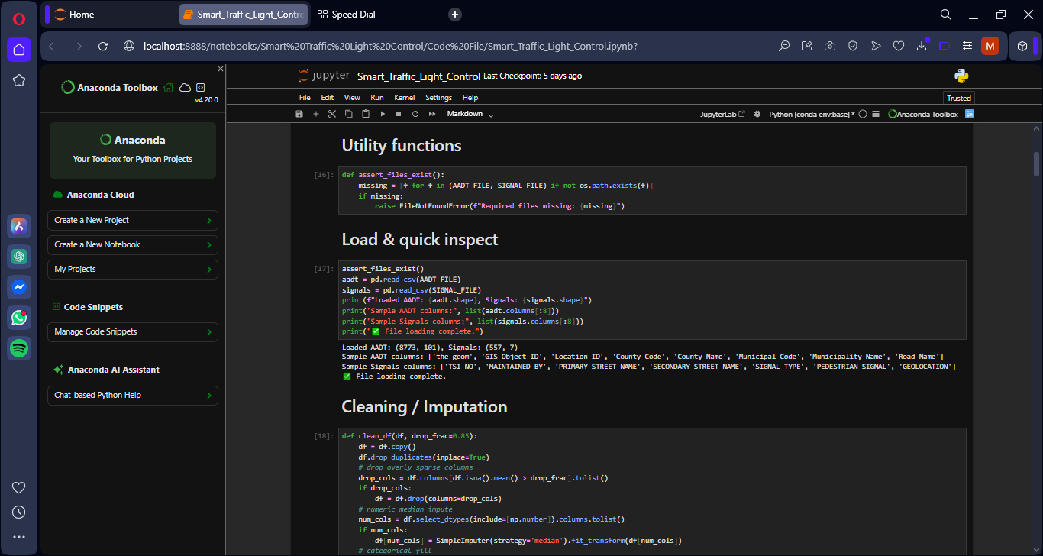
- Cleaning:
• Handle missing values using SimpleImputer (mean/median).
• Drop redundant or irrelevant columns.
• Encode categorical features if present.
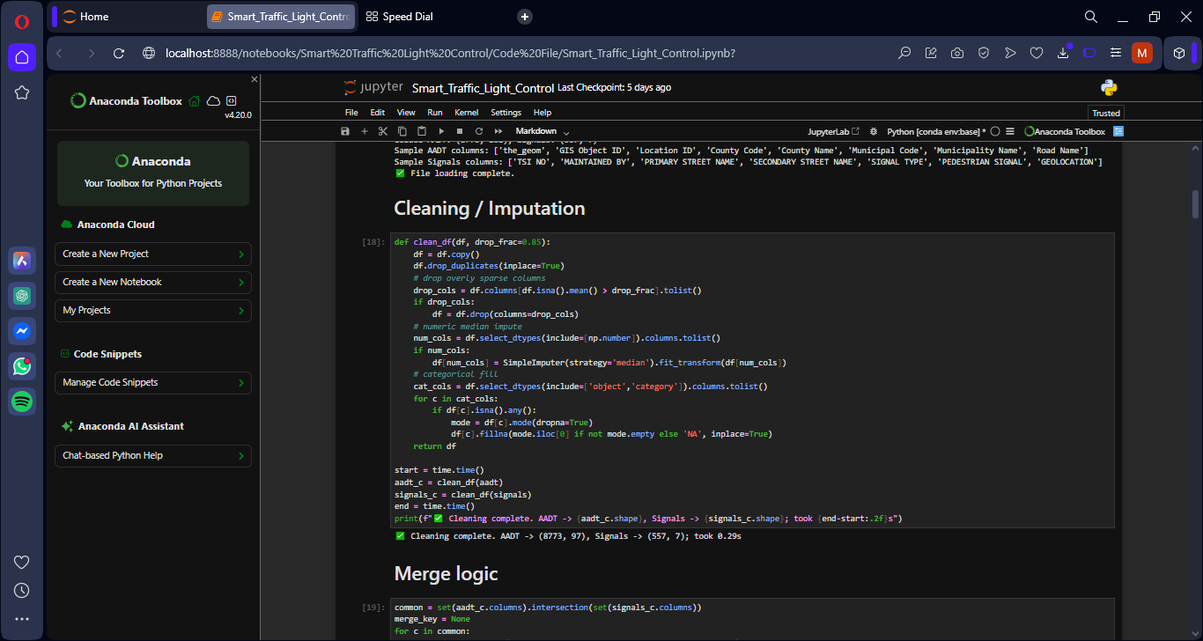
- Feature Construction:
• Merge numeric features from both datasets into a unified DataFrame.
• Derive a target variable representing congestion (based on volume, flow rate, and waiting time).
- Scaling and Splitting:
• Apply StandardScaler for normalization.
• Perform an 80/20 split using train_test_split for consistent evaluation.
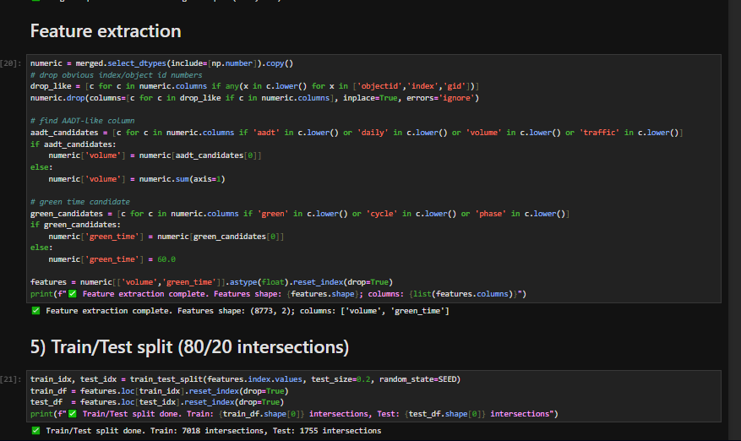
These steps ensure uniform data preparation for both CSP and DQN models.

5. Methodology

Multi-Agent CSP
• Each intersection acts as an independent agent with multiple signal phase options.
• Local and neighbor costs are defined to represent congestion and coordination penalties.
• A local search or greedy algorithm minimizes the total cost across intersections.
• The final configuration (ma_solution) serves as the baseline against which DQN performance is compared.

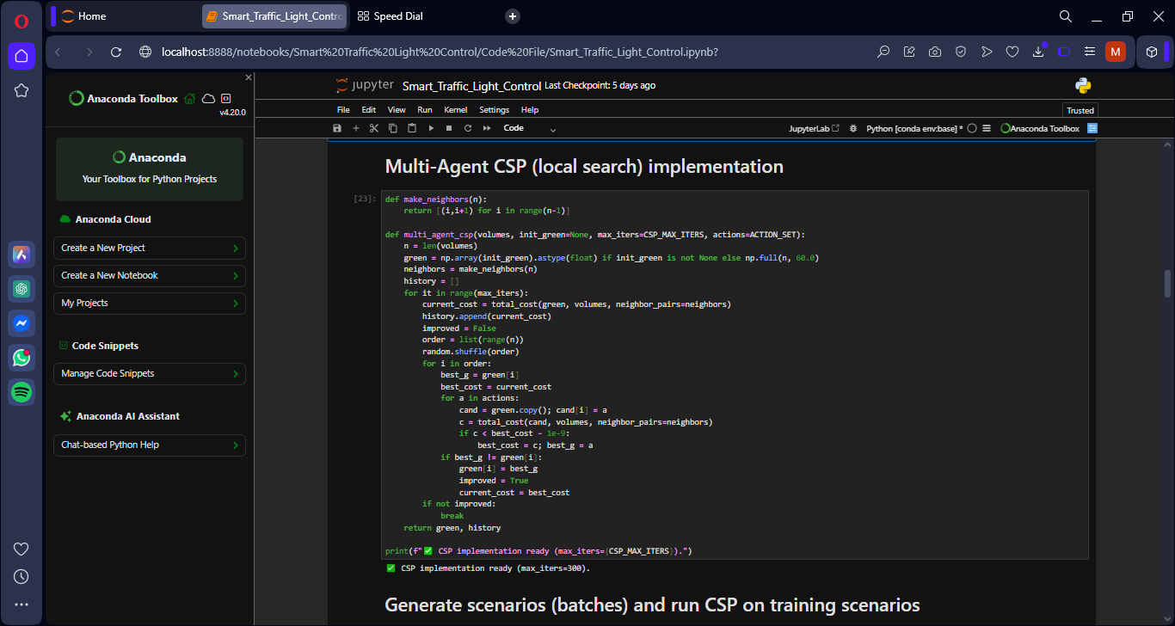
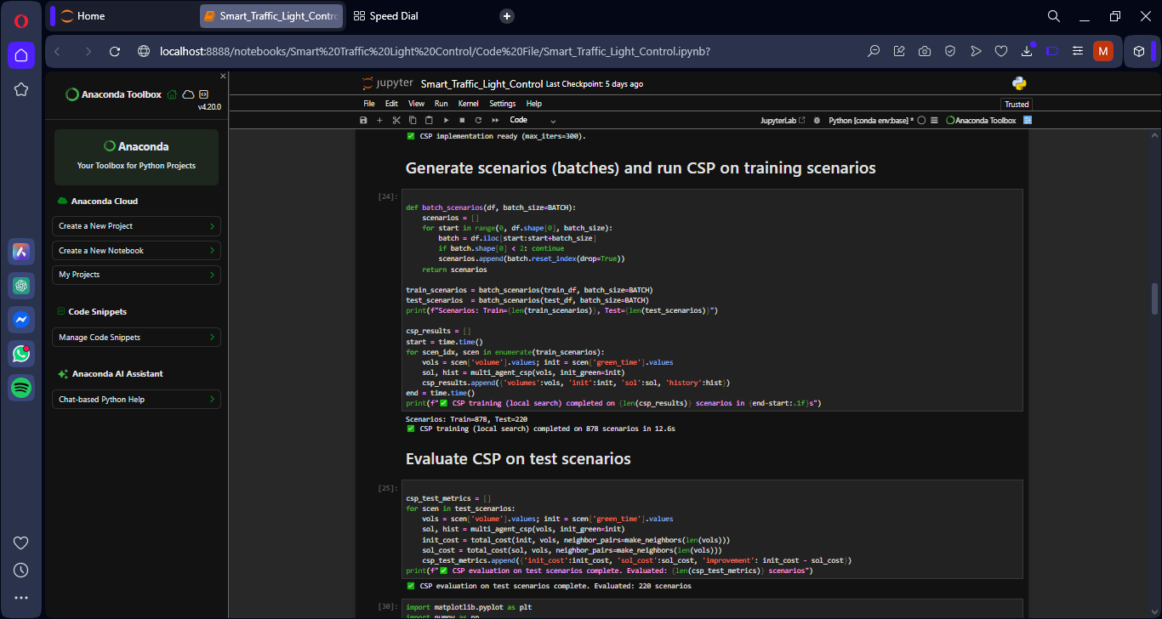
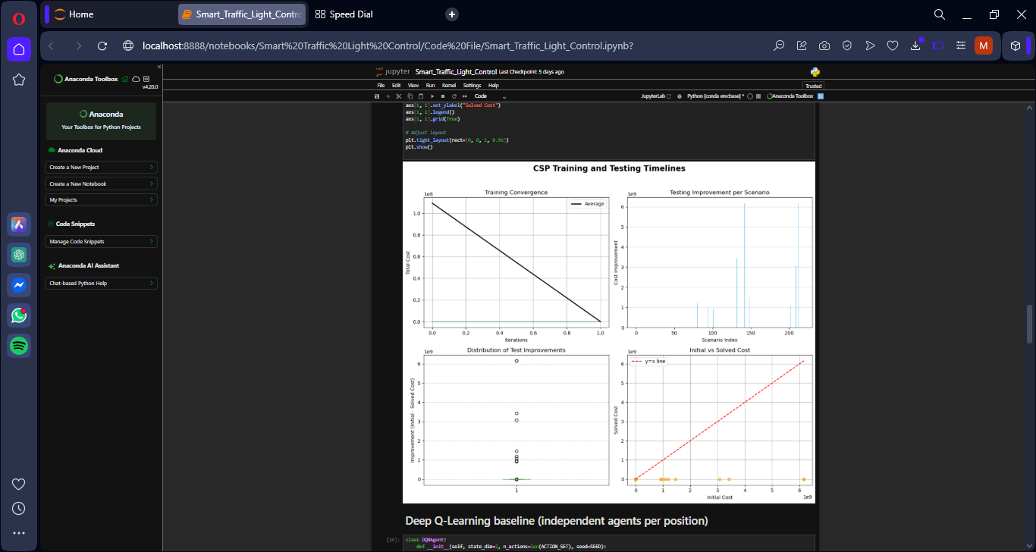

5.2 Deep Q-Learning (DQN)
• State: Vector representing real-time traffic features (flow rate, density, queue length).
• Action: Selection of the next signal phase or green time duration.
• Reward: Negative congestion cost; lower congestion yields higher reward.
• Neural Network: A PyTorch-based model mapping states to Q-values (expected rewards).
• Training Loop:
o Experience replay memory for stability.
o Epsilon-greedy exploration for balance between learning and exploitation.
o Mean Squared Error (MSE) loss for Q-value updates.
o Optimizer: Adam or RMSprop.
The DQN model learns optimal signal timing policies through repeated episodes, improving traffic throughput dynamically.

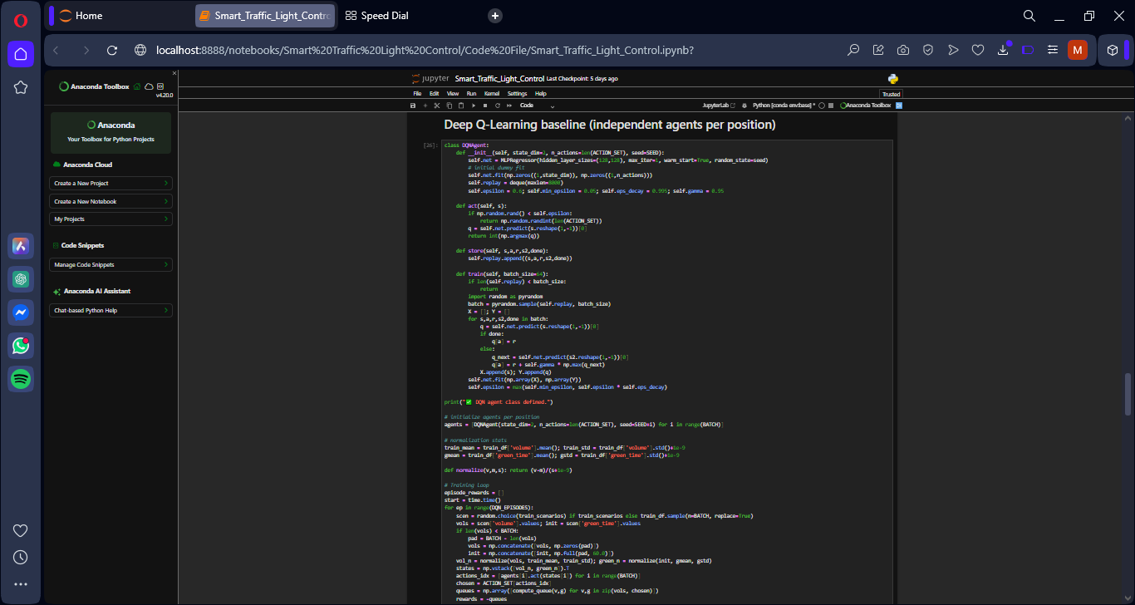
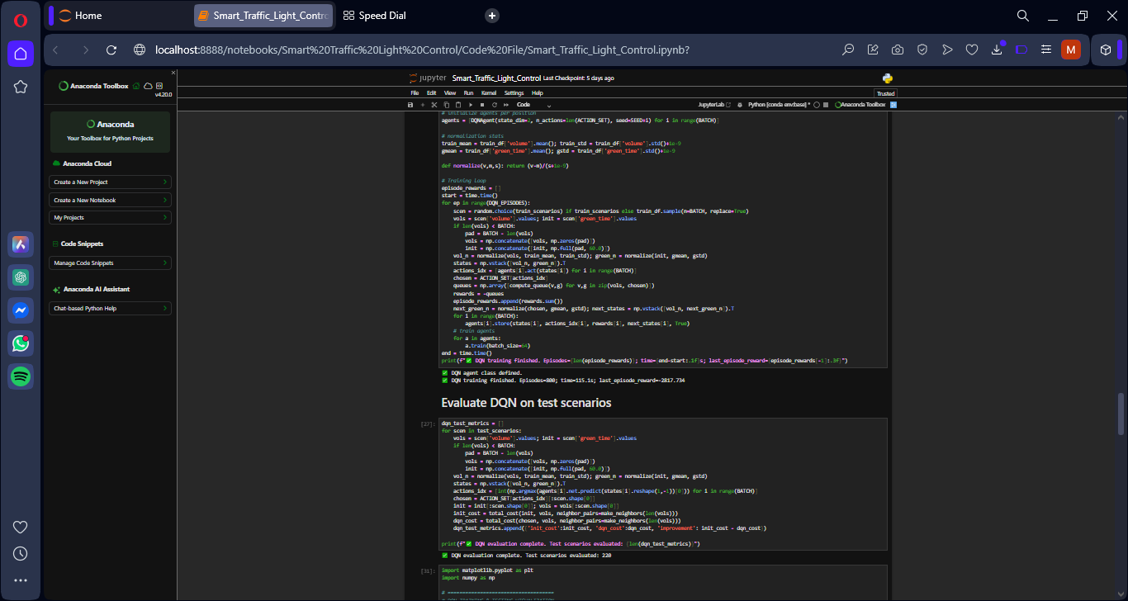
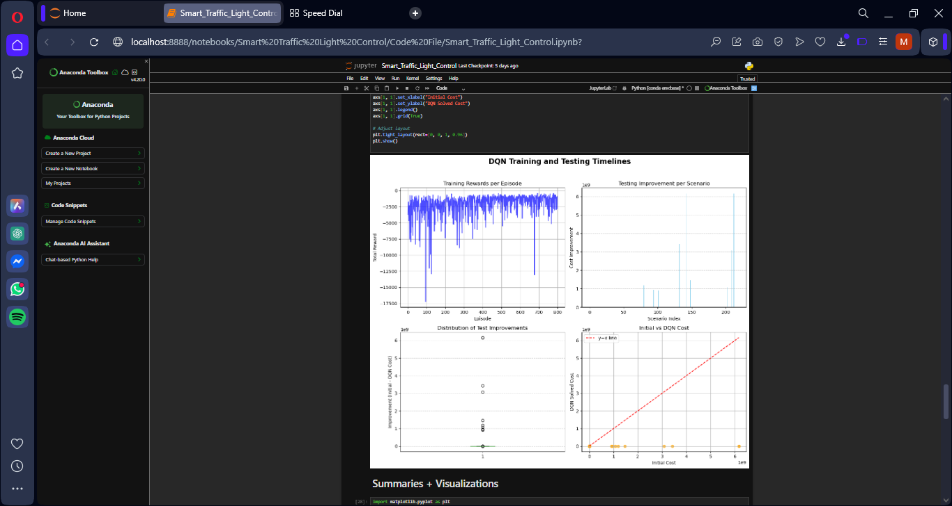

7. Experiments and Results
Experiments were conducted using the prepared datasets and identical train/test splits for both models.
CSP Results:
• Converged quickly to a stable configuration.
• Produced consistent but static results across iterations.
DQN Results:
• Showed progressive improvement in average rewards.
• Demonstrated superior adaptability to dynamic traffic variations.
Comparison Summary:
• DQN achieved lower congestion scores on test data.
• Visualization plots confirmed CSP’s early stability and DQN’s long-term improvement.
• DQN outperformed CSP in adaptability, generalization, and reduction of overall congestion cost.
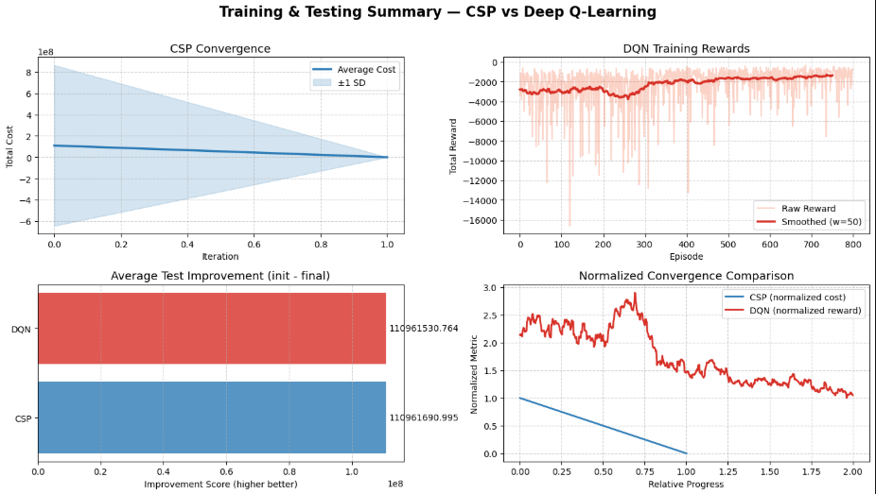

8. Discussion and Limitations
Strengths:
• Direct comparison reveals practical differences in algorithm behavior.
• Data preprocessing ensures consistent evaluation conditions.
• DQN’s reinforcement learning capability enables flexible policy generation.
Limitations:
• Lack of a high-fidelity traffic simulator limits real-world generalization.
• DQN training is computationally expensive.
• CSP scalability decreases with a higher number of intersections.
Reproducibility Notes:
• Random seeds set for numpy, torch, and random to ensure consistency.
• Saved trained models and normalization scalers for later inference.

9. Conclusion and Future Work
This project concludes that Deep Q-Learning (DQN) performs better than Multi-Agent CSP for adaptive traffic control.
While CSP offers structured and quick baseline optimization, DQN provides flexible, data-driven adaptability for varying traffic conditions.
Future Work:
• Integrate real-time sensor data from smart intersections.
• Implement multi-agent reinforcement learning (e.g., MADDPG, QMIX).
• Simulate large-scale scenarios using SUMO.
• Optimize training parameters for faster convergence.

